1. **Find instructions for downloading latest XS information from TCI here:**
   1. **R:\Production\MLA\Files for MLA Processing\XSELL\XSELL TCI DECSION LENDER.txt**
   2. **Follow instructions in above text file.**
2. **Open SAS**
3. **At top ribbon, click Program > Open Program > Pull – FBXMITA**
4. **See what is highlighted below for the segments of each line that needs to be modified. When going into a new month, you will need to create a folder called “ITA” to send the files to. As seen here, 10-16 would be the day of the pull. Generally, this is the only part of the date you will change as year obviously changes once a year.**

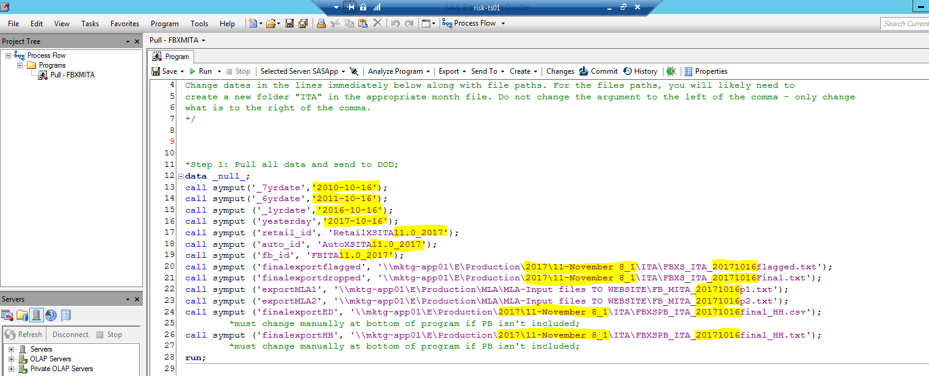

1. **Go down to approximately line 1149 and type “/*” to comment out what is below this line.**

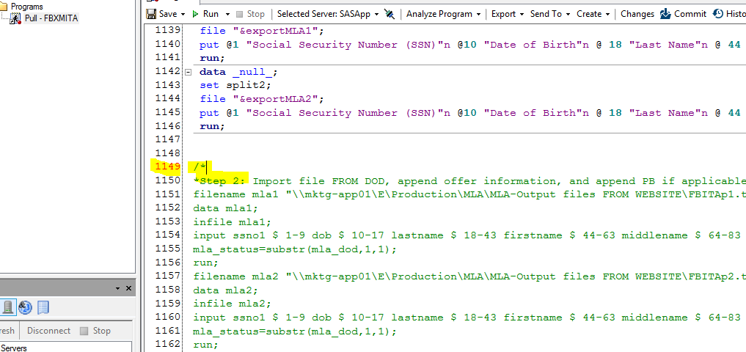

1. **Hit F3 to run the program.**
2. **You will see the below after the run. Copy the first table for the waterfall. The rest of the output is to note that everything executed as expected. R:Production\MLA\Waterfall_02)FB ITA Monthly.xlsx**

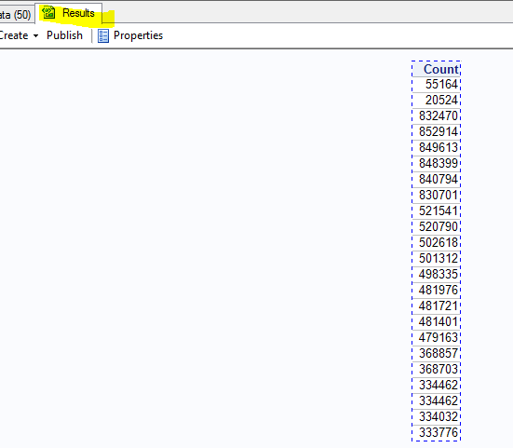

1. **Open up Internet Explorer**
   1. **Go to:** [**https://mla.dmdc.osd.mil/mla/#/home**](https://mla.dmdc.osd.mil/mla/#/home)
   2. **At the top ribbon, Click “Multiple Record Requests”**
   3. **Enter in your username and password information.**
   4. **Click “Add.” Add, one at a time, the MLA input files for the current pull. (R:Production\MLA\MLA-Input files TO WEBSITE\ FB_MITA_20171016p1 and R:Production\MLA\MLA-Input files TO WEBSITE\ FB_MITA_20171016p2). The “20171016” portion changes according to how you changed the date in the pull code.**
   5. **Select “Yes” for “Do you require certificates for the uploaded files?”**
   6. **Check both boxes beneath as shown below.**
   7. **Click “Upload.”**

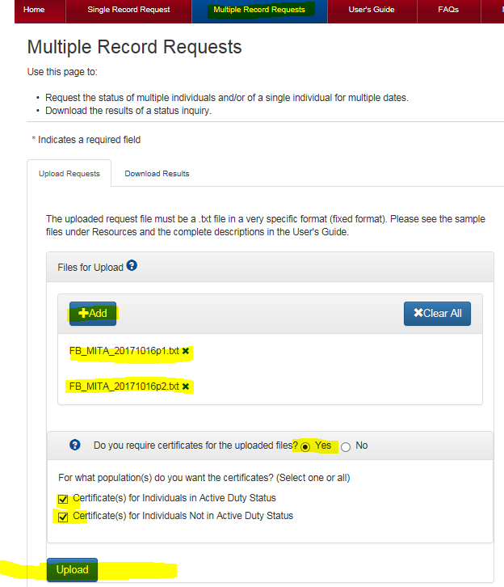

* 1. **If it is a success, you will see “File Uploaded” as shown below. If it is, click on “Download Results” as circled below in blue.**

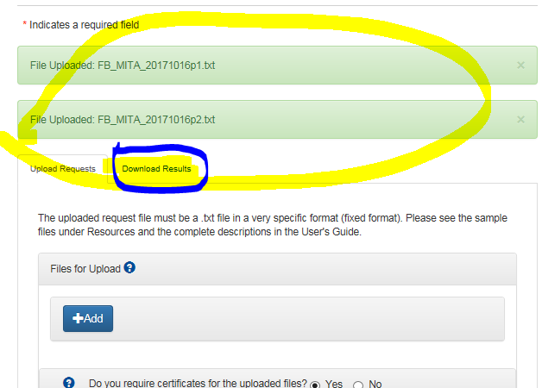

* 1. **You will notice the hourglass indicating that it is not yet ready, as shown below.**

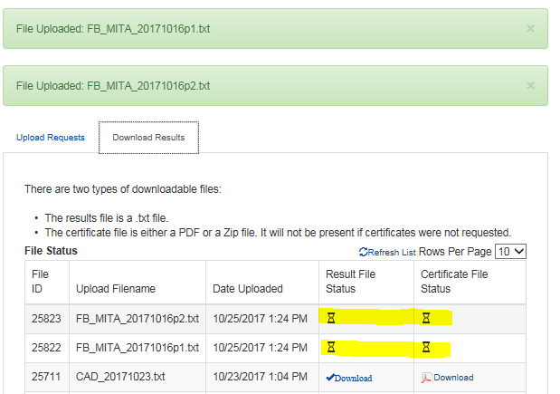

* 1. **You might have to exit out and sign back in, but generally I just click around the website a few times and when I come back to the page it is finished. But, it will definitely not show as finished if you stay on the page.**
  2. **When it is finished, the icons will change as shown below:**

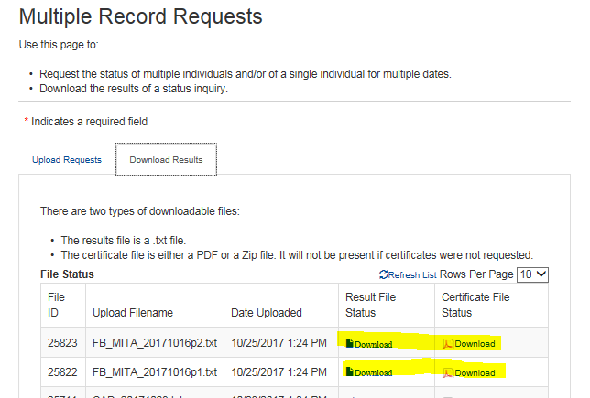

* 1. **Click on the first file, then select Save > Save As then save it as it is already named as in the location seen below:**

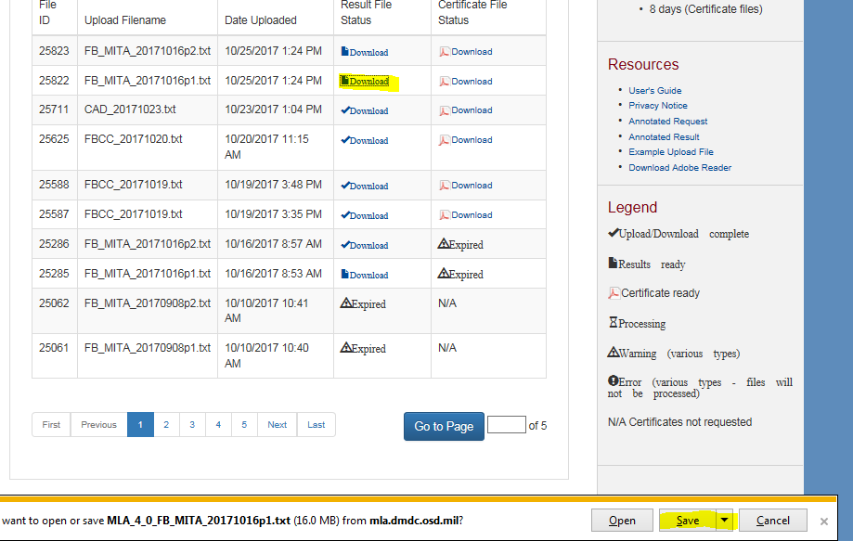

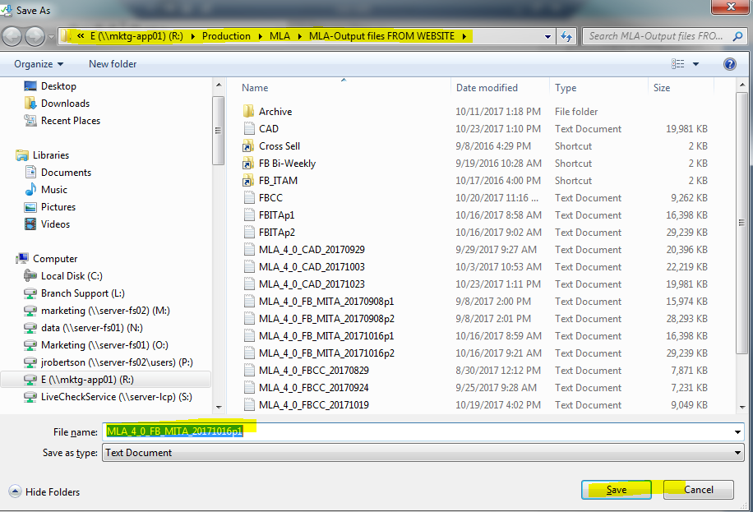

* 1. **Next, Click the file again, Save > Save As, but this time save as FBITAp1 as highlighted below. Yes, overwrite existing file.**

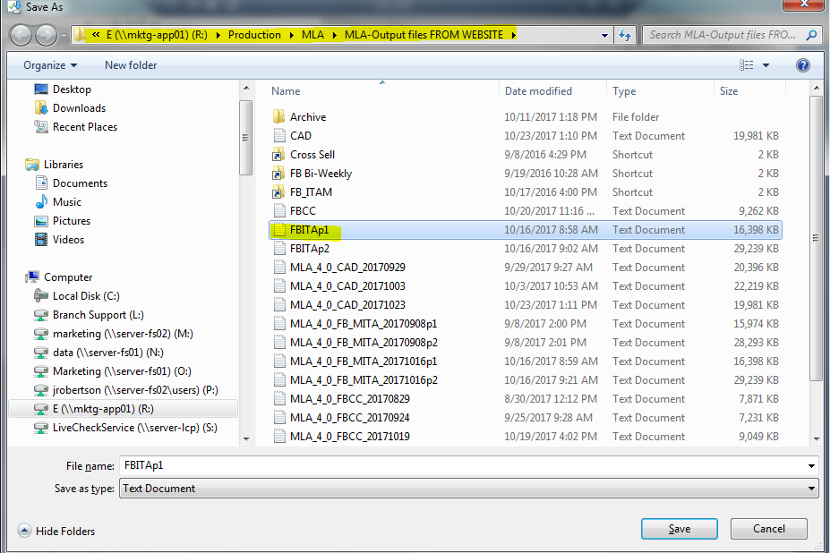

* 1. **Repeat Process for the second file and save twice, once as it is already named, once as FBITAp2.**
  2. **Click on the pdf icon under “Certificate File Status” to save certificates for both files. Select PDF Format, as seen below. Then Save > Save As and without changing the name (but choosing the proper location), save as seen below. Do the same for both files.**

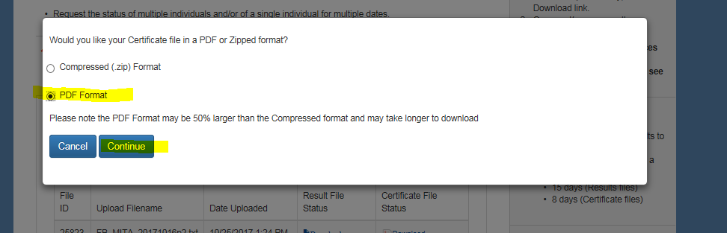

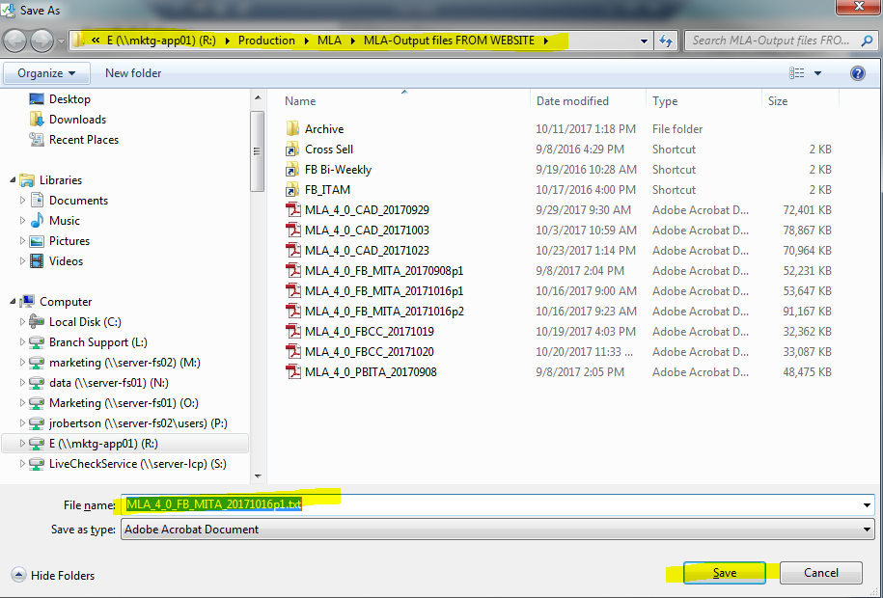

1. **Go back to code, around line 1149, and remove the “/*”**
2. **Highlight from 1149 up to line (approx.) 1245, before the comment “*append pbita”**
3. **Hit F3.**
4. **If PB is included, refer to “Pull Instructions – PBITA” before continuing.**
5. **If PB is included and you have finished executing what is inside “Pull Instructions – PBITA”, proceed as follows (else continue to 14.)**
   1. **Highlight line 1247 – 1267 (at “*append pbita;” ending after the “proc freq” procedure).**
   2. **Hit F3. Check output tables to ensure the offers are populating correctly and to copy MLA counts into the waterfall.**
   3. **Add PBITA count to the end of FBXMITA waterfall.**
   4. **Send Ed McMurray an email with the filepath of the last two proc export procedures letting him know they are complete.**
6. **No PB – Skip to line 1270.**
   1. **highlight line 1270 (“*For when pbita isn’t included”) to the end.**
   2. **Hit F3. Check output table to ensure the offers are populating correctly and to copy MLA counts into the waterfall.**
   3. **Send Ed McMurray an email with the filepath of the last two proc export procedures letting him know they are complete.**
7. **Click Program > Open Program > Audit – FBXMITA – Pre HH**
   1. **Run the program. The only modifications to the code that are needed are adding or removing the comment blocks if PB is not or is included ( /* and */)**
   2. **Go to the file location and rename it according to the name of the campaign.**
   3. **I.e.** \\mktg-app01\E\Production\Audits\FBXSPB ITA AUDIT Pre HH.xlsx to "\\mktg-app01\E\Production\Audits\FBXSPB ITA 10.0 AUDIT Pre HH.xlsx"